# Task

You are challenged to design a thing. That thing must show your design and engineering skills and has the following constraints:

* It should take no longer than 3 hours 40 minutes of class time to product
* It must be a flatpack design that can be cut out a single piece of A4 cardboard.
* It must be something mechanised and controlled by an arduino.
* You must have a concept design for what the end product should look like. These concept designs must be sketched on pencil and paper.
* You must have boxes and arrow design for the code of an arduino
* Your must have a CAD design that shows how the entire project will come together
* You must have a diagram from CAD that prints for the Laser Cutter.
* Your overall output must be sufficient for a third party to build your design
* Your overall design must feel like it is appropriately scaled to reality.

Note you must also submit:

A “script” of how you respond to the following questions:

* When designing a system, how do you present/communicate complex ideas to technical and/or non-technical users?
* Provide an example of how your design provides some level of innovative (to you) or high quality design and how you approached this concept.

Example of a thing:

Concieve and design a Railway crossing with a boom arm that is appropriatly scaled so it looks appropriate in size to a real railway crossing with a boomarm.

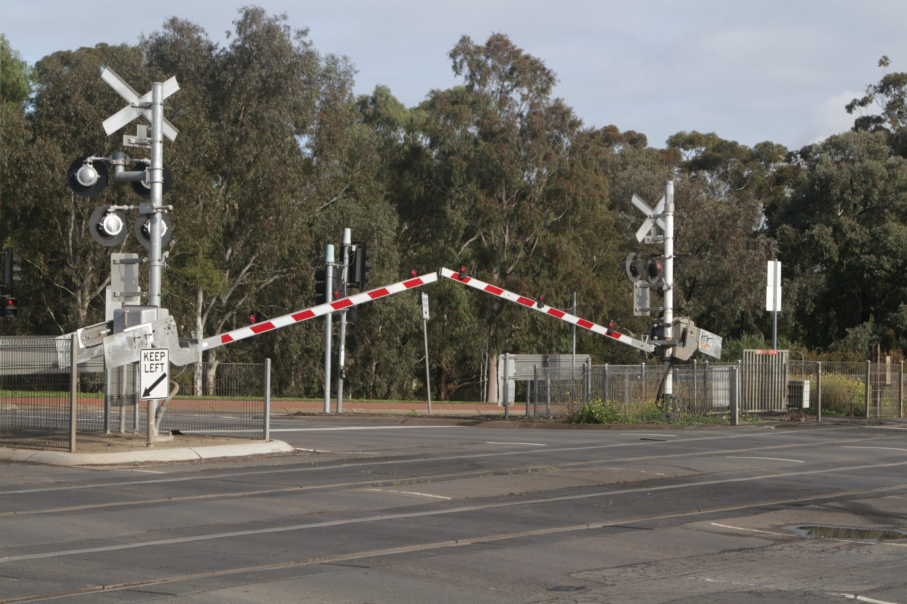

## Instruments of assessments

At the heart of enegineering is the ability to articulate complex ideas to both technical and non-techncial users. In this unit, we use CAD tools built up on on basic sketching and paper concepts.

### Assessment Guide

* Is your design likely to be built by someone else who can’t deviate from the plan?
* Have you got sketches?
* Have you thought how you are going make it work?
* Have you got boxes and arrows for code design?
* Have you got a CAD design?
* When you bring it down to a drawing, does it all fit on an A4 page?
* The script